Author: Mahesh Santosh Bhakare

Employee ID: API2309

Batch: Greenfield Training Batch 31

Title: 1. Use String,StringBuffer,StringBuilder in java.

**Source Code:**

**package** com.apisero.greenfield;

**public** **class** Assignment1 {

**public** **static** **void** main(String[] args) {

System.***out***.println("String: ");

String s1 = **new** String("Good Bye");

String s2 = **new** String("Good Bye");

System.***out***.println("Length of s1: " + s1.length());

System.***out***.println("Char at 3rd index in s1 : " + s1.charAt(3));

System.***out***.println("Substring od s1: " + s1.substring(5, 7));

System.***out***.println("Should s1 contains Bye: " + s1.contains("Bye"));

System.***out***.println("Is s1 equals to s2: " + s1.equals(s2));

System.***out***.println("Replace y by i in s1: " + s1.replace('y', 'i'));

System.***out***.println("Concat s1 and s2: " + s1.concat(s2));

System.***out***.println("Upper case of s1: " + s1.toUpperCase());

System.***out***.println("Lower case of s1: " + s1.toLowerCase());

System.***out***.println("index of d in s1: " + s1.indexOf('d'));

System.***out***.println("Original string s1: " + s1);

System.***out***.println();

System.***out***.println("-----------------------------------------------------------");

System.***out***.println();

System.***out***.println("String Buffer: ");

StringBuffer s3 = **new** StringBuffer(s1);

s3.append(" Hii");

System.***out***.println("s3 after appending hii: " + s3);

s3.insert(8, " Guys ");

System.***out***.println("after inserting Guys in s3: " + s3);

System.***out***.println("Capacity of s3: " + s3.capacity());

s3.delete(8, 13);

System.***out***.println("After deleting between index 8 to 13: " + s3);

System.***out***.println();

System.***out***.println("-----------------------------------------------------------");

System.***out***.println();

System.***out***.println("String Builder: ");

StringBuilder s4 = **new** StringBuilder(s1);

System.***out***.println("String created with String Builder: " + s4);

}

}

**Output:**

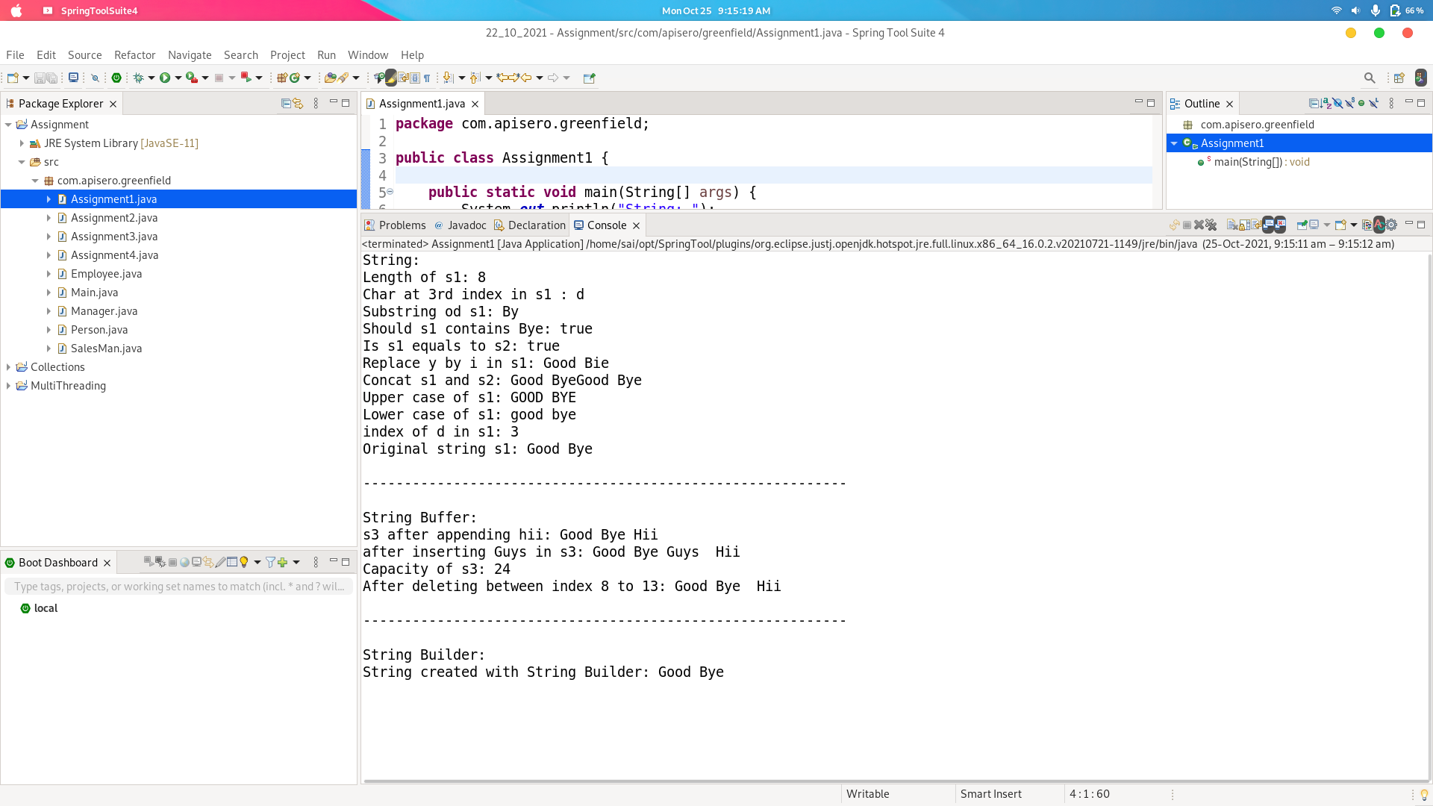

Title: 2. Accept and display String and its addresses using String,StringBuffer,StringBuilder

**Source Code:**

**package** com.apisero.greenfield;

**public** **class** Assignment2 {

**public** **static** **void** main(String[] args) {

String s = **new** String("ABC");

System.***out***.println("Accepted String is: "+s);//calls to string method to print string which is overrided from object class to string class

System.***out***.println("Hashcode of String is: "+s.hashCode());

System.***out***.println("\n---------------------------------------------\n");

StringBuffer sb = **new** StringBuffer("Google");

System.***out***.println("Accepted String is: "+sb);

System.***out***.println("Hashcode of String is: "+sb.hashCode());

System.***out***.println("\n---------------------------------------------\n");

StringBuilder sbb = **new** StringBuilder("Village");

System.***out***.println("Accepted String is: "+sbb);

System.***out***.println("Hashcode of String is: "+sbb.hashCode());

}

}

**Output:**

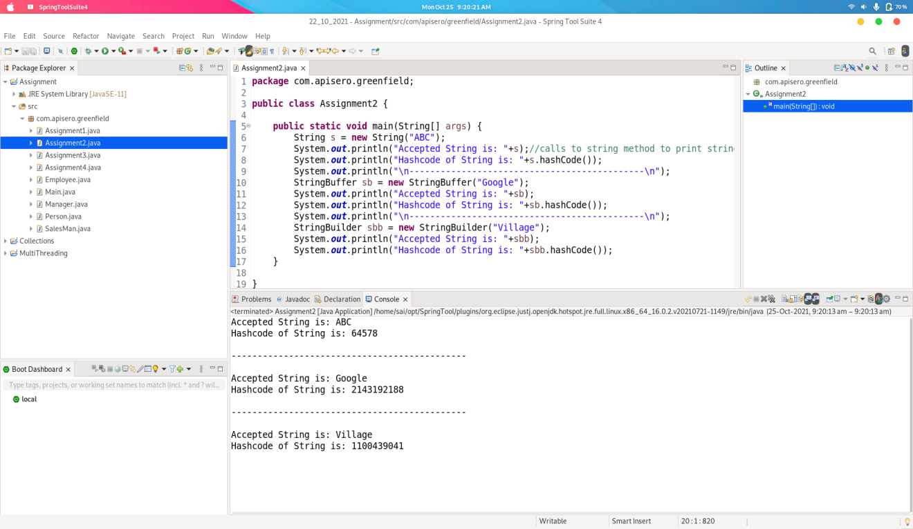

Title : 3. Create AutoBoxing and UnBoxing for All data types in Java.

**Source Code:**

**package** com.apisero.greenfield;

**import** java.util.Scanner;

**public** **class** Assignment3 {

**public** **void** ByteAutoBoxUnBox()

{

System.***out***.println("Byte: ");

**byte** i = 10;

Byte j = i;

System.***out***.println("Autoboxing of byte: "+j);

**byte** k = j;

System.***out***.println("AutoUnboxing of Byte: "+k);

System.***out***.println("\n--------------------------------------------------------------\n");

}

**public** **void** ShortAutoBoxUnBox()

{

System.***out***.println("Short: ");

**short** i = 10;

Short j = i;

System.***out***.println("Autoboxing of short: "+j);

**short** k = j;

System.***out***.println("AutoUnboxing of Short: "+k);

System.***out***.println("\n--------------------------------------------------------------\n");

}

**public** **void** IntegerAutoBoxUnBox()

{

System.***out***.println("Integer: ");

**int** i = 10;

Integer j = i;

System.***out***.println("Autoboxing of int: "+j);

**int** k = j;

System.***out***.println("AutoUnboxing of Integer: "+k);

System.***out***.println("\n--------------------------------------------------------------\n");

}

**public** **void** FloatAutoBoxUnBox()

{

System.***out***.println("Float: ");

**float** i = 10.34f;

Float j = i;

System.***out***.println("Autoboxing of float: "+j);

**float** k = j;

System.***out***.println("AutoUnboxing of Float: "+k);

System.***out***.println("\n--------------------------------------------------------------\n");

}

**void** DoubleAutoBoxUnBox()

{

System.***out***.println("Double: ");

**double** i = 12.15;

Double j = i;

System.***out***.println("Autoboxing of double: "+j);

**double** k = j;

System.***out***.println("AutoUnboxing of Double: "+k);

System.***out***.println("\n--------------------------------------------------------------\n");

}

**void** CharacterAutoBoxUnBox()

{

System.***out***.println("Character: ");

**char** i ='a';

Character j = i;

System.***out***.println("Autoboxing of char: "+j);

**char** k = j;

System.***out***.println("AutoUnboxing of Character: "+k);

System.***out***.println("\n--------------------------------------------------------------\n");

}

**void** BooleanAutoBoxUnBox()

{

System.***out***.println("Boolean: ");

**boolean** i = **true**;

Boolean j = i;

System.***out***.println("Autoboxing of boolean: "+j);

**boolean** k = j;

System.***out***.println("AutoUnboxing of Boolean: "+k);

System.***out***.println("\n--------------------------------------------------------------\n");

}

**void** LongAutoBoxUnBox()

{

System.***out***.println("Long: ");

**long** i = 10;

Long j = i;

System.***out***.println("Autoboxing of long: "+j);

**long** k = j;

System.***out***.println("AutoUnboxing of Long: "+k);

System.***out***.println("\n--------------------------------------------------------------\n");

}

**public** **static** **void** main(String[] args) {

Assignment3 a3 = **new** Assignment3();

**int** choice;

**char** ch;

**try** (Scanner sc = **new** Scanner(System.***in***)) {

System.***out***.println("-----------------------------------------------------");

**do**

{

System.***out***.println("-----------------------------------------------------");

System.***out***.print("1. Byte\n2. Short\n3. Integer\n4. Long\n5. Float\n6. Double\n7. Character\n8. Boolean\nEnter Your Choice: ");

choice = sc.nextInt();

**switch**(choice)

{

**case** 1:

a3.ByteAutoBoxUnBox();

**break**;

**case** 2:

a3.ShortAutoBoxUnBox();

**break**;

**case** 3:

a3.IntegerAutoBoxUnBox();

**break**;

**case** 4:

a3.LongAutoBoxUnBox();

**break**;

**case** 5:

a3.FloatAutoBoxUnBox();

**break**;

**case** 6:

a3.DoubleAutoBoxUnBox();

**break**;

**case** 7:

a3.CharacterAutoBoxUnBox();

**break**;

**case** 8:

a3.BooleanAutoBoxUnBox();

**break**;

**default**:

System.***out***.println("Enter Proper Choice....");

}

System.***out***.print("Do you want to Continue: ");

ch = sc.next().charAt(0);

}**while**(ch == 'y');

}

**catch**(Exception e)

{

e.printStackTrace();

}

}

}

**Output:**

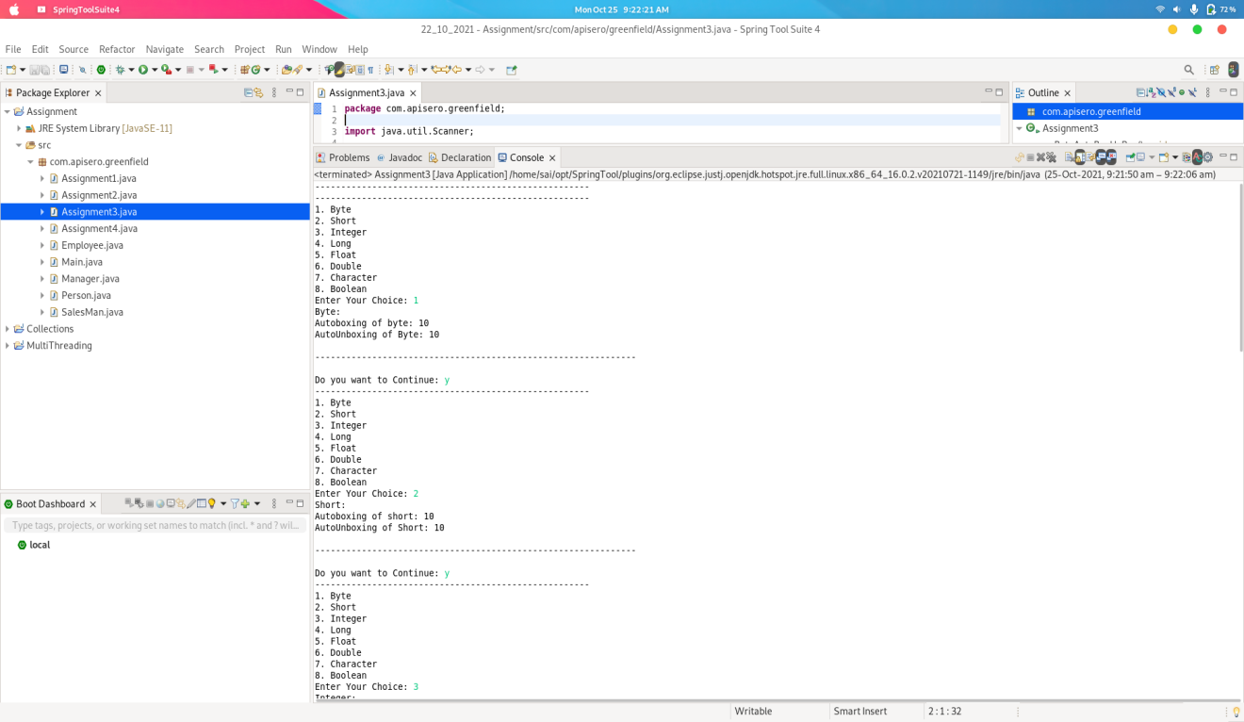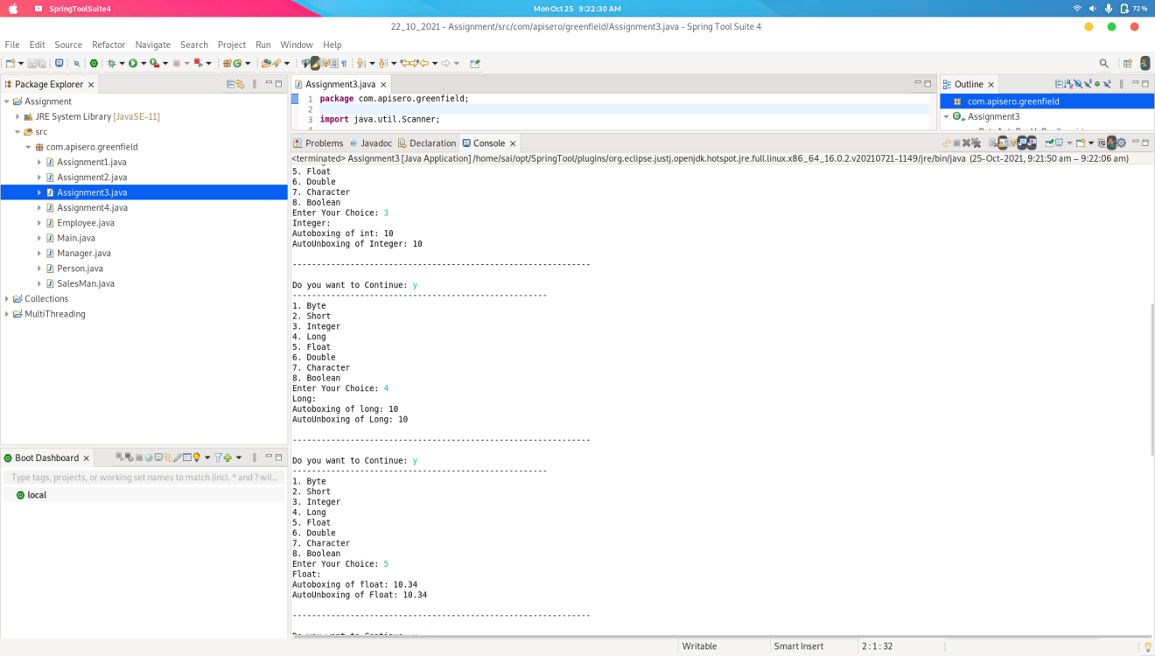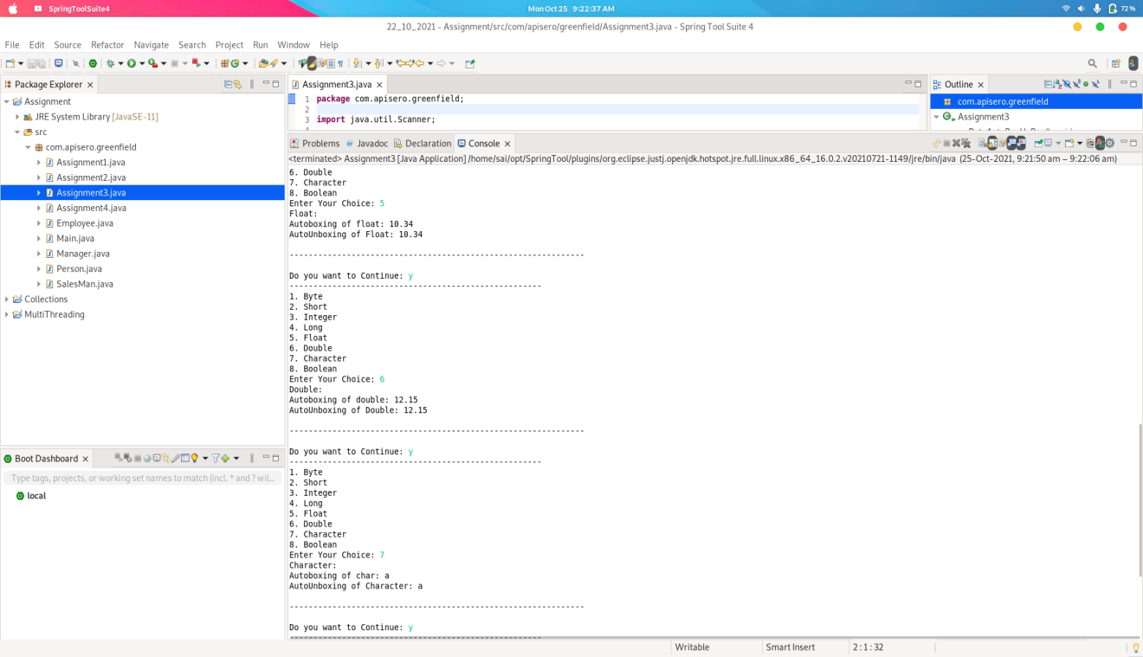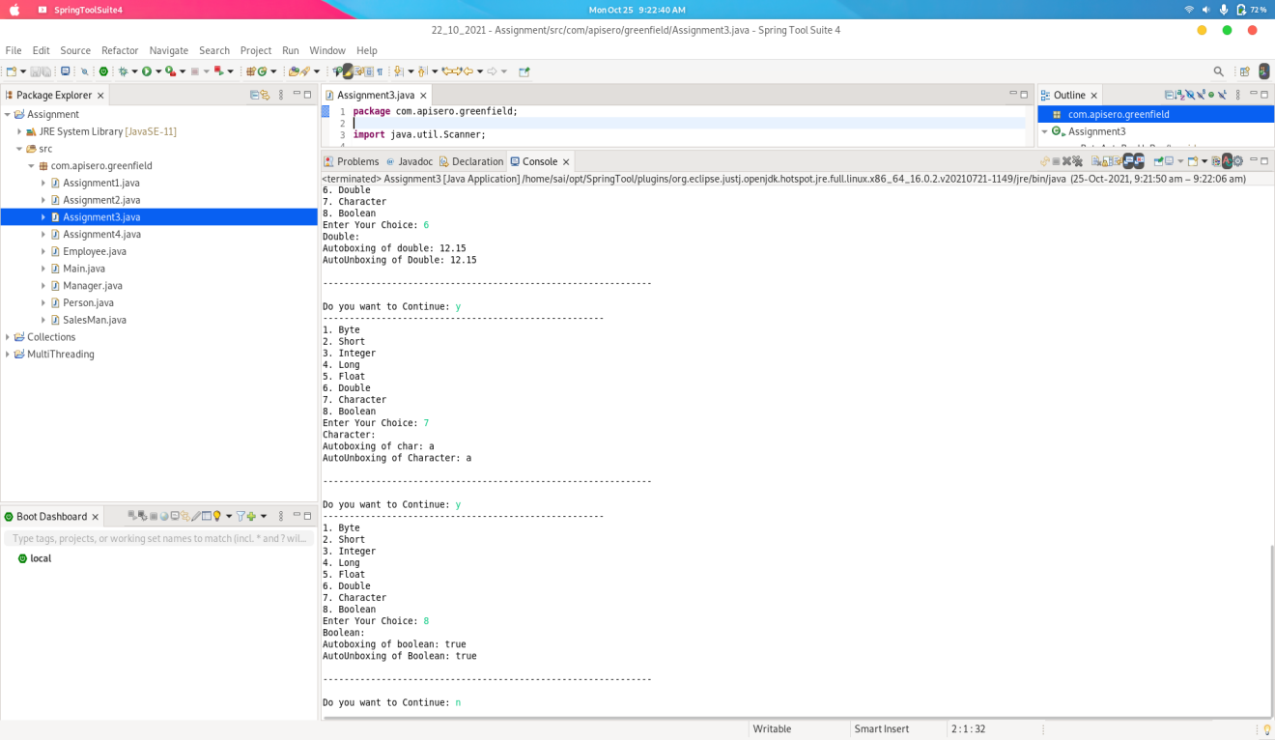

Title: 4. Overload Addition function

**Source Code:**

**package** com.apisero.greenfield;

**public** **class** Assignment4 {

**public** **int** Addition(**int** num1, **int** num2)

{

**return** num1+num2;

}

**public** **int** Addition(**int** num1, **int** num2, **int** num3)

{

**return** num1+num2+num3;

}

**public** **static** **void** main(String[] args) {

Assignment4 a4 = **new** Assignment4();

System.***out***.println("Addition of two numbers: "+a4.Addition(10, 20));

System.***out***.println("Addition of three numbers: "+a4.Addition(30, 40, 50));

}

}

**Output:**

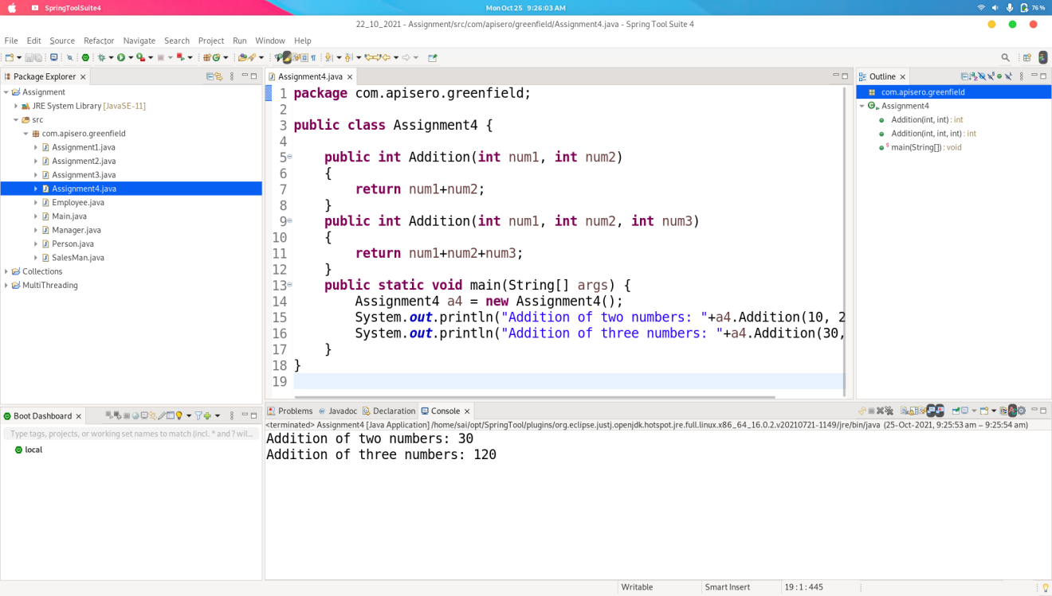

Title: 5. Override function in Multilevel Inheritance.

Title: 6. Single,Multilevel and Hierarchical inheritance with any real time objects.

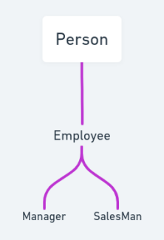

**Source Code:**

Person.java

**package** com.apisero.greenfield;

**public** **class** Person {

**private** String name;

**private** **int** age;

**private** String address;

**public** Person(String name, **int** age, String address) {

**super**();

**this**.name = name;

**this**.age = age;

**this**.address = address;

}

**public** String getName() {

**return** name;

}

**public** **void** setName(String name) {

**this**.name = name;

}

**public** **int** getAge() {

**return** age;

}

**public** **void** setAge(**int** age) {

**this**.age = age;

}

**public** String getAddress() {

**return** address;

}

**public** **void** setAddress(String address) {

**this**.address = address;

}

@Override

**public** String toString() {

**return** "Person [name=" + name + ", age=" + age + ", address=" + address + "]";

}

}

Employee.java

**package** com.apisero.greenfield;

**public** **class** Employee **extends** Person {

**private** String id;

**private** **double** salary;

**public** Employee(String id, String name, **int** age, String address, **double** salary) {

**super**(name, age, address);

**this**.id = id;

**this**.salary = salary;

}

**public** String getId() {

**return** id;

}

**public** **void** setId(String id) {

**this**.id = id;

}

**public** **double** getSalary() {

**return** salary;

}

**public** **void** setSalary(**double** salary) {

**this**.salary = salary;

}

**public** **double** calculateSalary() {

**return** salary;

}

@Override

**public** String toString() {

**return** "Employee [" + **super**.toString() + "id=" + id + ", salary=" + salary + "]";

}

}

Manager.java

**package** com.apisero.greenfield;

**public** **class** Manager **extends** Employee {

**private** **double** bonus;

**public** Manager(String id, String name,**int** age, String address, **double** salary, **double** bonus) {

**super**(id, name, age, address, salary);

**this**.bonus = bonus;

}

**public** **double** getBonus() {

**return** bonus;

}

**public** **void** setBonus(**double** bonus) {

**this**.bonus = bonus;

}

**public** **double** calculateSalary() {

**return** **this**.getSalary() + bonus;

}

@Override

**public** String toString() {

**return** "Manager ["+**super**.toString()+"bonus=" + bonus + "]";

}

}

SalemsMan.java

**package** com.apisero.greenfield;

**public** **class** SalesMan **extends** Employee {

**public** **double** incentive;

**public** SalesMan(String id, String name, **int** age, String address, **double** salary, **double** incentive) {

**super**(id, name, age, address, salary);

**this**.incentive = incentive;

}

**public** **double** getIncentive() {

**return** incentive;

}

**public** **void** setIncentive(**double** incentive) {

**this**.incentive = incentive;

}

**public** **double** calculateSalary() {

**return** **this**.getSalary() + incentive;

}

@Override

**public** String toString() {

**return** "SalesMan [" + **super**.toString() + "incentive=" + incentive + "]";

}

}

Main.java

**package** com.apisero.greenfield;

**public** **class** Main {

**public** **static** **void** main(String[] args) {

Employee e = **new** Employee("API10", "XYZ",21, "PQR", 510000.00);

Manager e1 = **new** Manager("API12", "OLM",27, "RYR", 510000.00, 2000.00);

SalesMan e2 = **new** SalesMan("API13", "LMN",39, "NTR", 510000.00, 1000.00);

System.***out***.println(e);

System.***out***.println(e1);

System.***out***.println(e2);

System.***out***.println("Salary is: "+e.calculateSalary());

System.***out***.println("Salary is: "+e1.calculateSalary());

System.***out***.println("Salary is: "+e2.calculateSalary());

}

}

**Output:**

